**FORMAN CHRISTIAN COLLEGE (A CHARTERED UNIVERSITY)**



**Technology Management**

**SECTION A**

**Team Members:**

**Hadi Hassan (Project Manager)**

**231469272**

**Shaheer-Ur-Rehman**

**231451798**

**Afnan Ahmed**

**231485855**

**Sheraz Khalid**

**21-10944**

Table of Contents

**Projects** 3

**Project1 For Assignment 3** 3

**Tasks:** 3

**Kanban:** 4

Gantt: 4

***Additional Reports:*** 5

**Deadline:** 5

**Planner:** 5

**Calendar:** 6

**Project 2** 6

**Tasks:** 6

**Kanban:** 7

**Gantt:** 8

***Additional Reports*** 8

**Deadline:** 8

**Planner:** 9

**Calander:** 9

**Scrum** 10

**Calendar for Meetings** 10

**Planing Task** 10

**Make Sprint** 11

**Start Sprint** 11

**Active Sprint** 12

**Completed Sprint** 12

**Projects**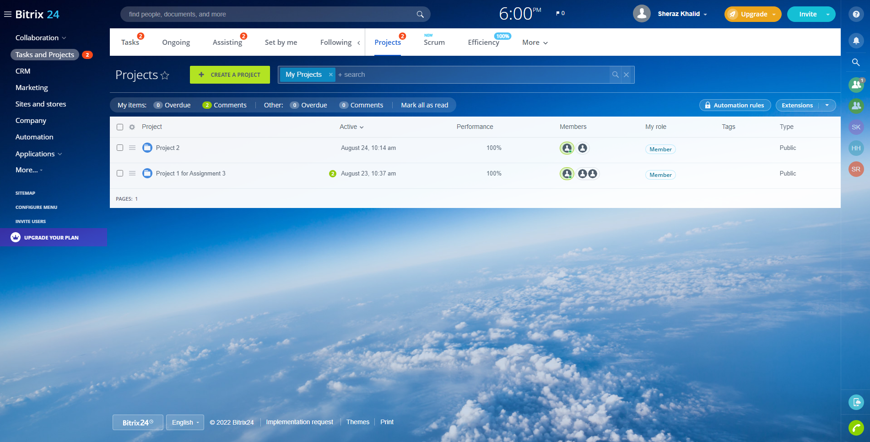

# **Project1 For Assignment 3**

## **Tasks:**

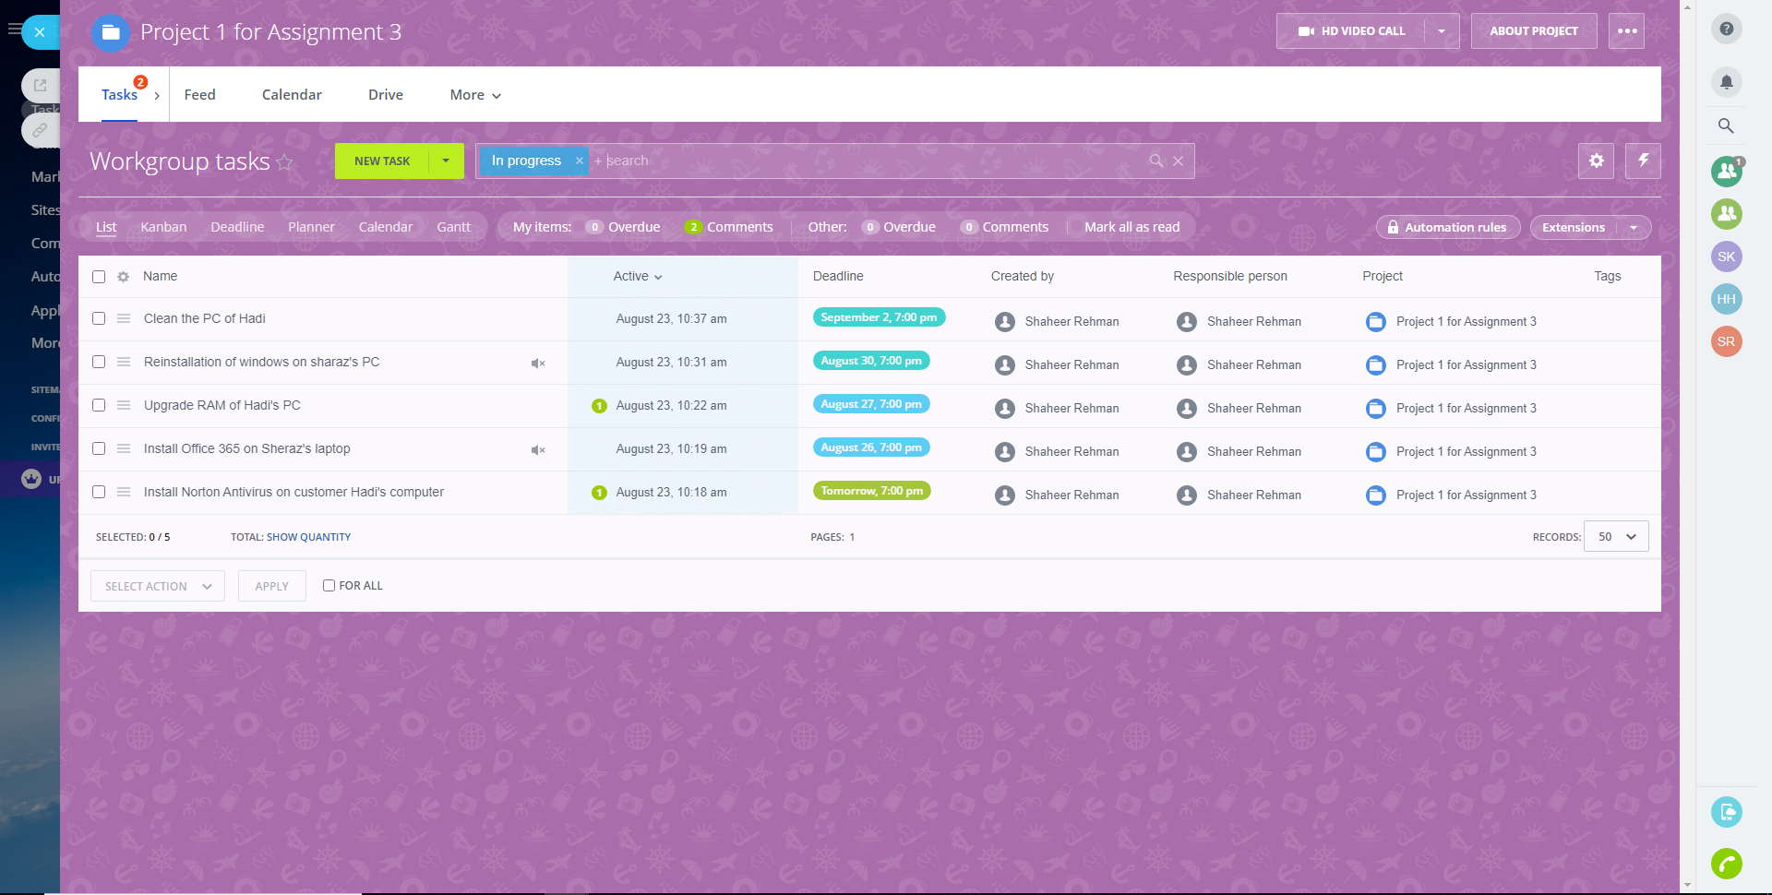

## **Kanban:**

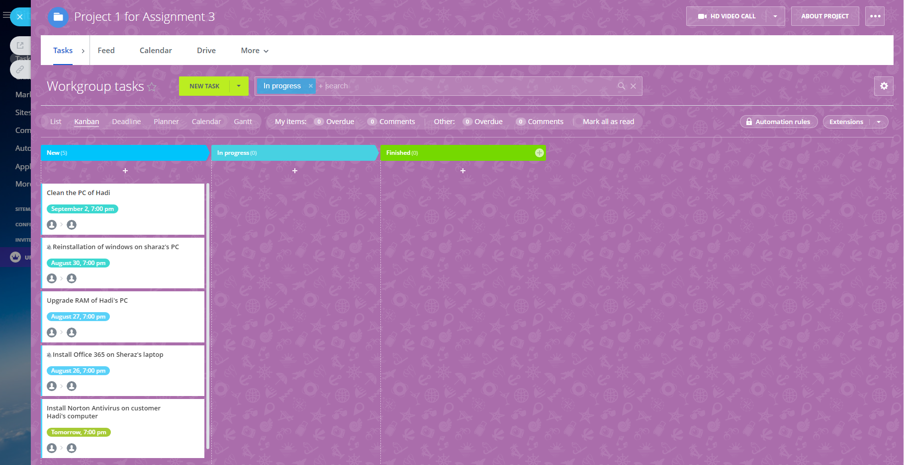

## Gantt:

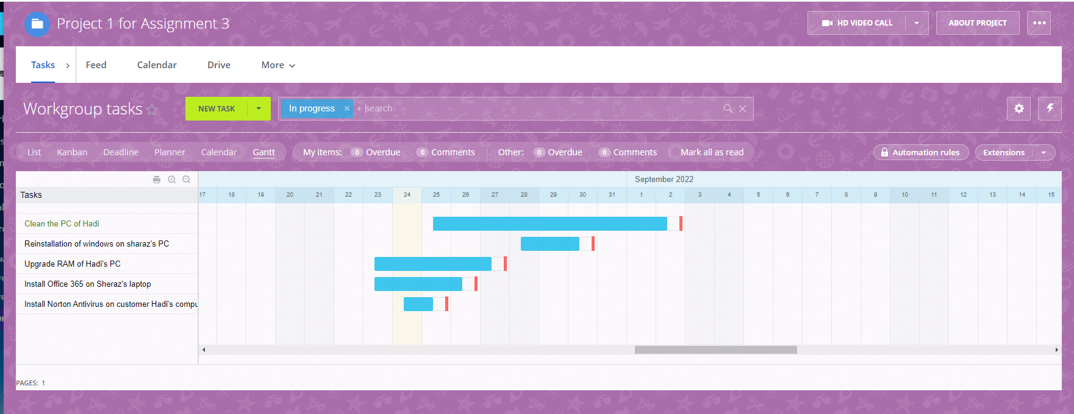

## ***Additional Reports:***

### **Deadline:**

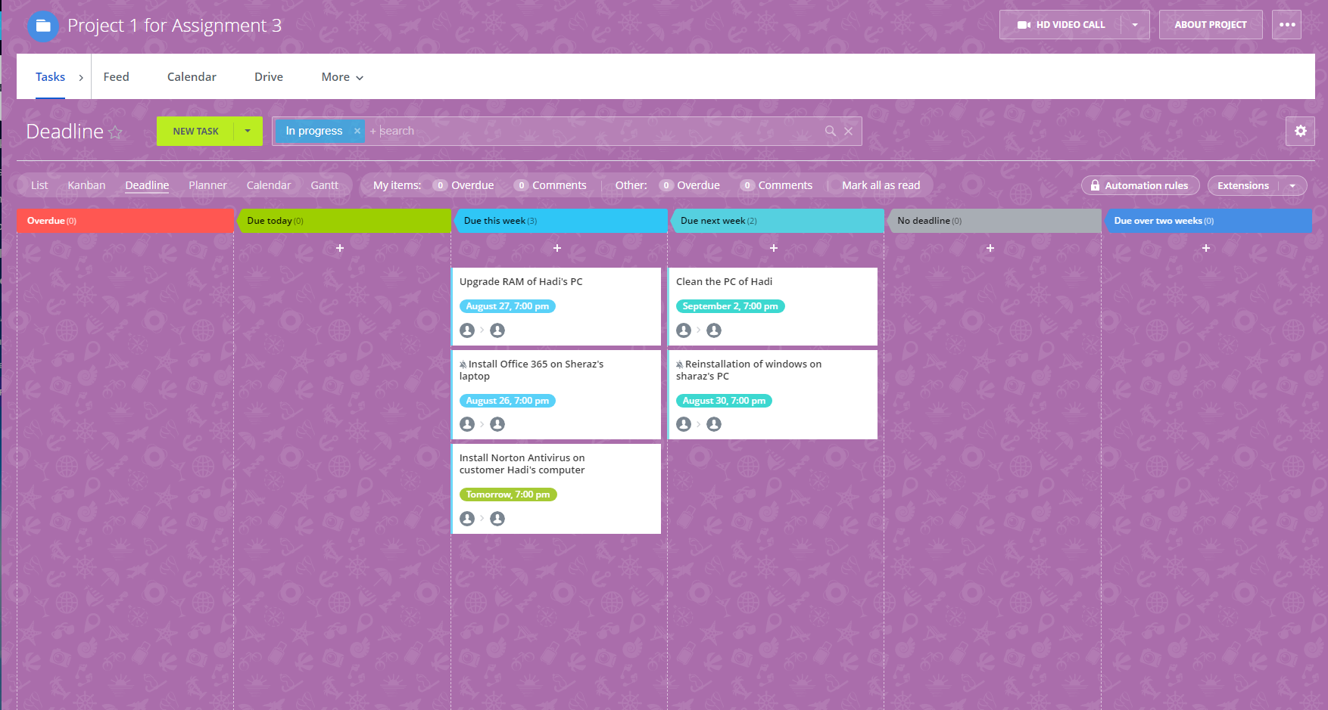

### **Planner:**

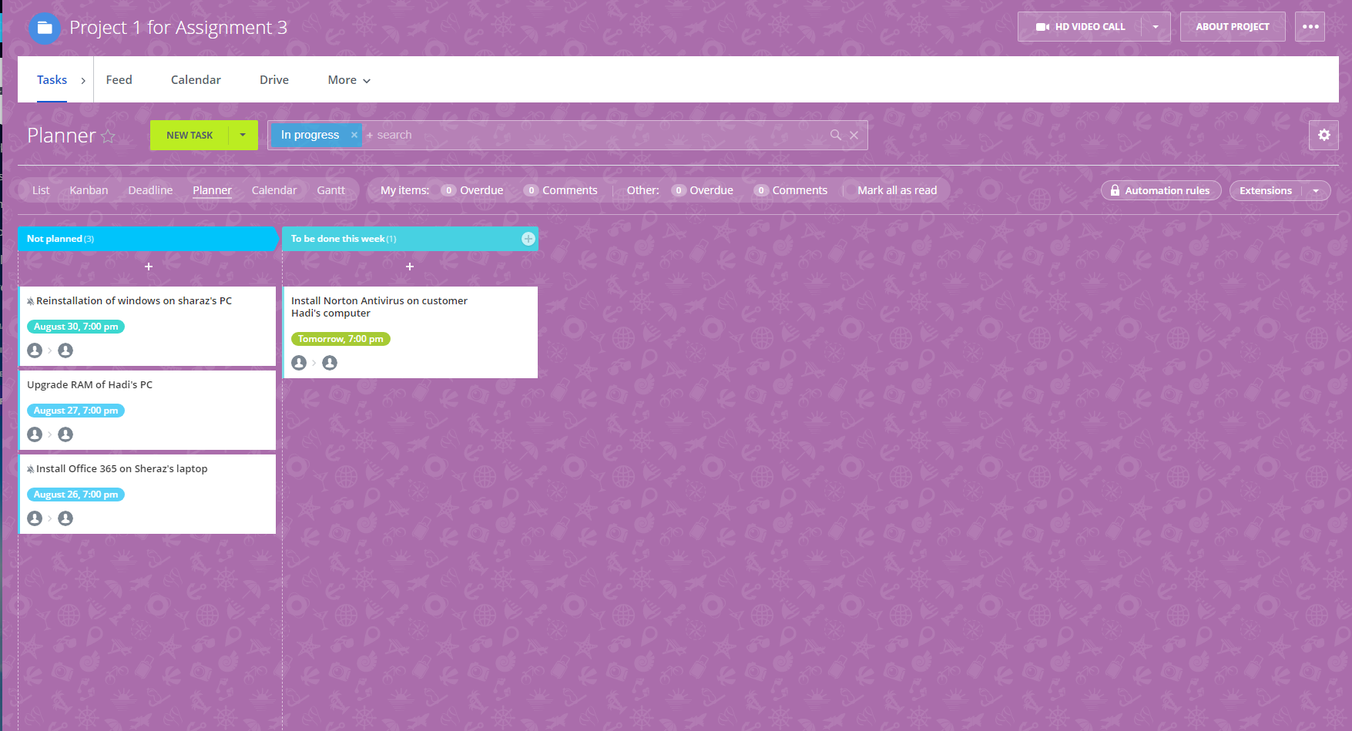

**Calendar:** 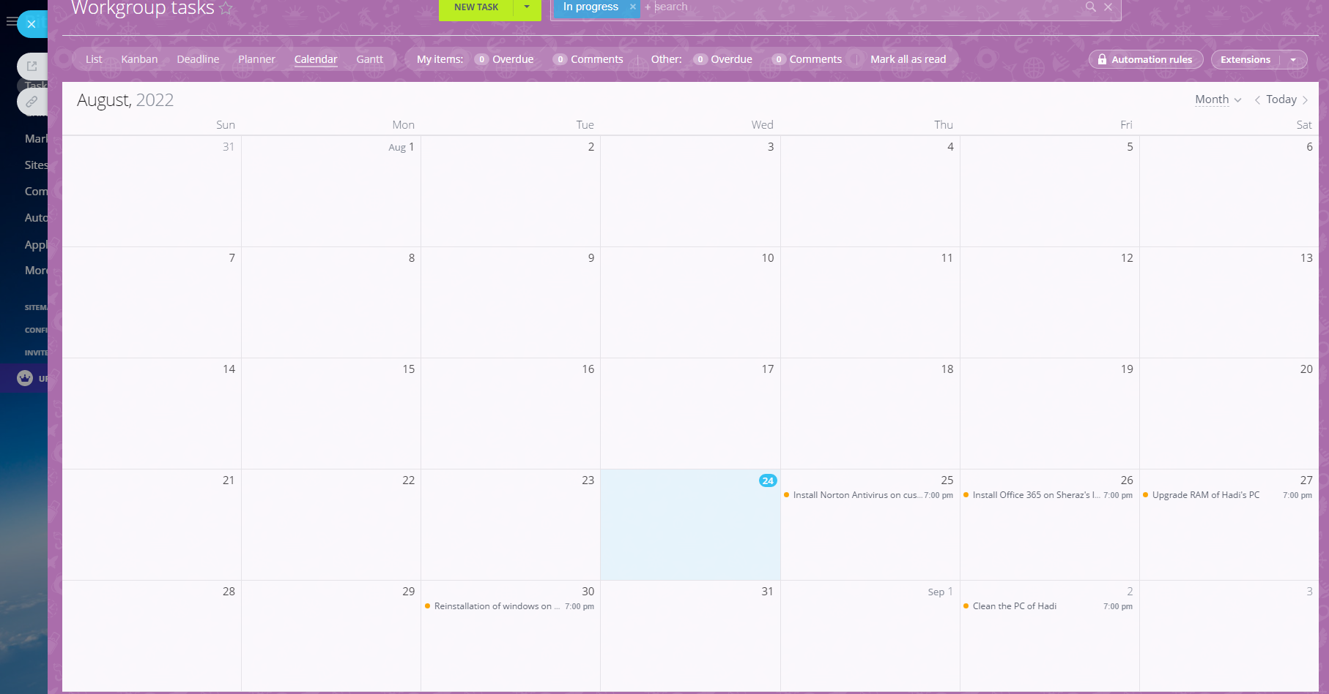

# **Project 2**

## **Tasks:**

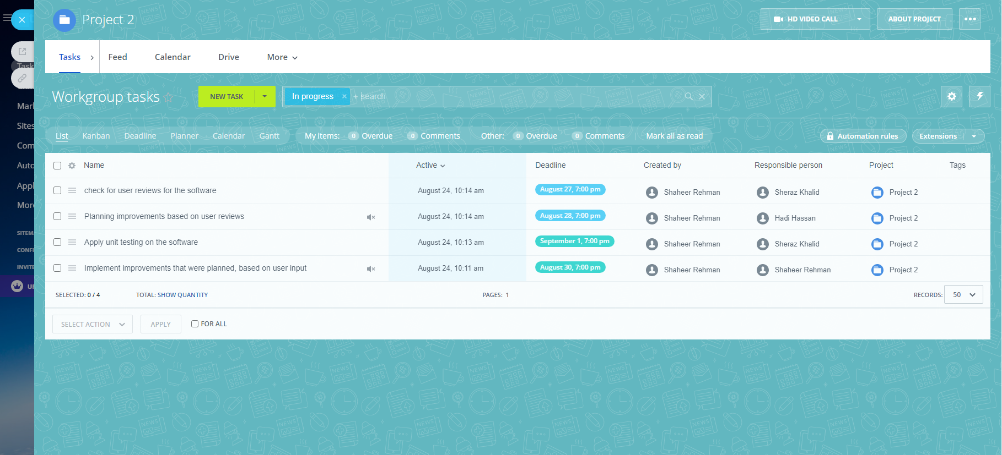

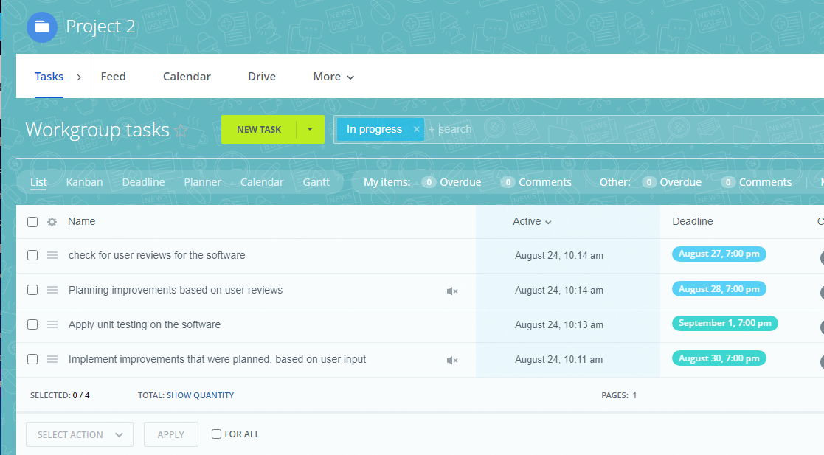

## **Kanban:**

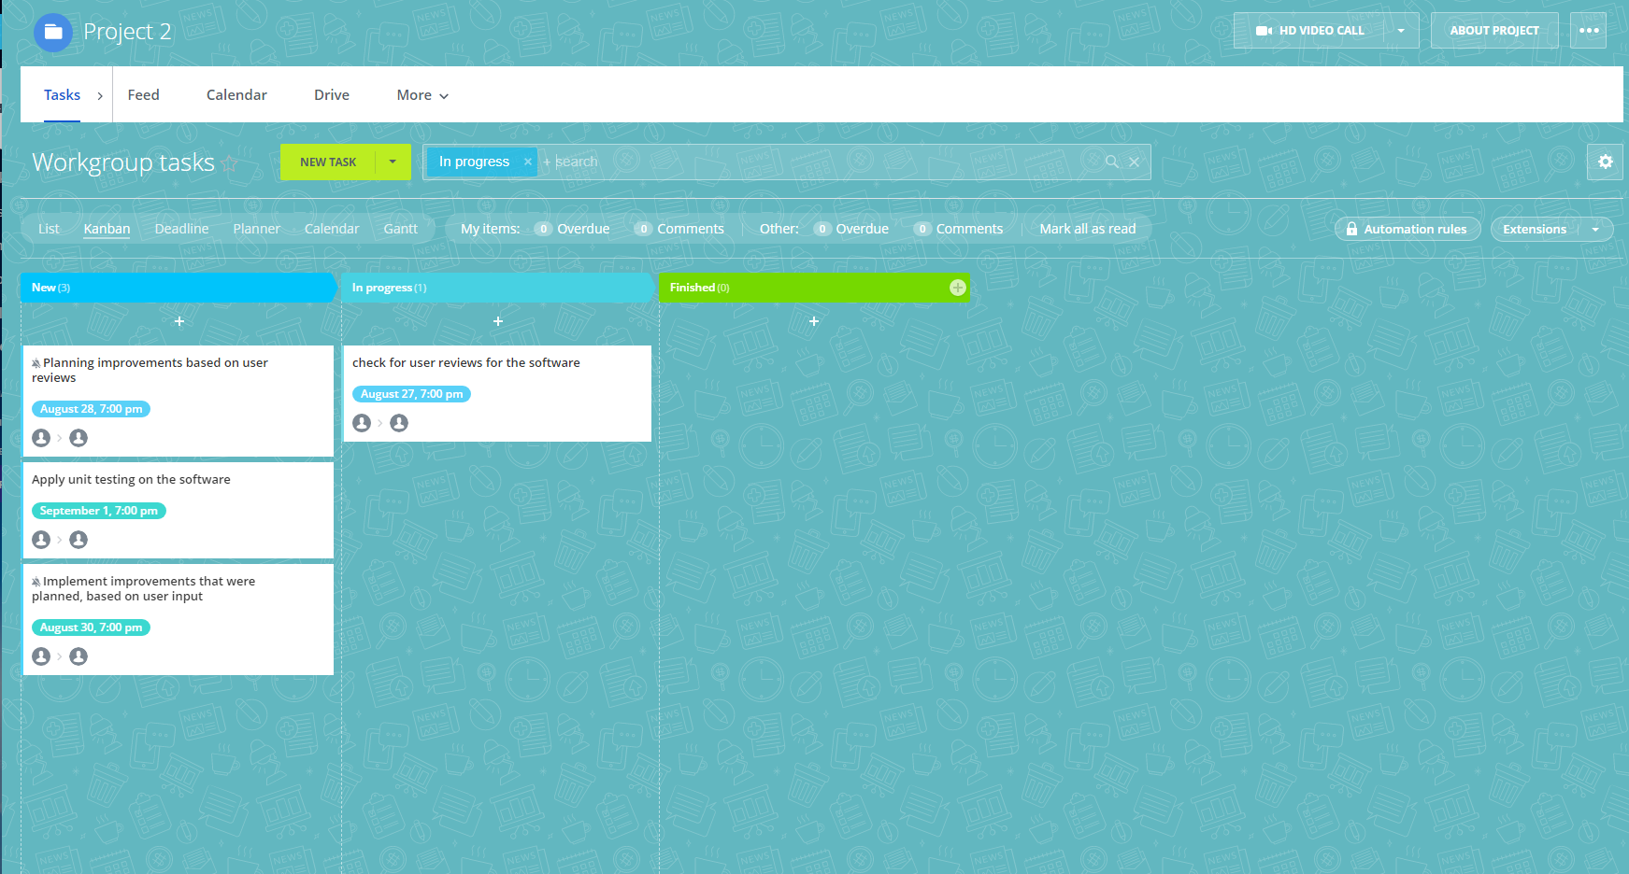

## **Gantt:**

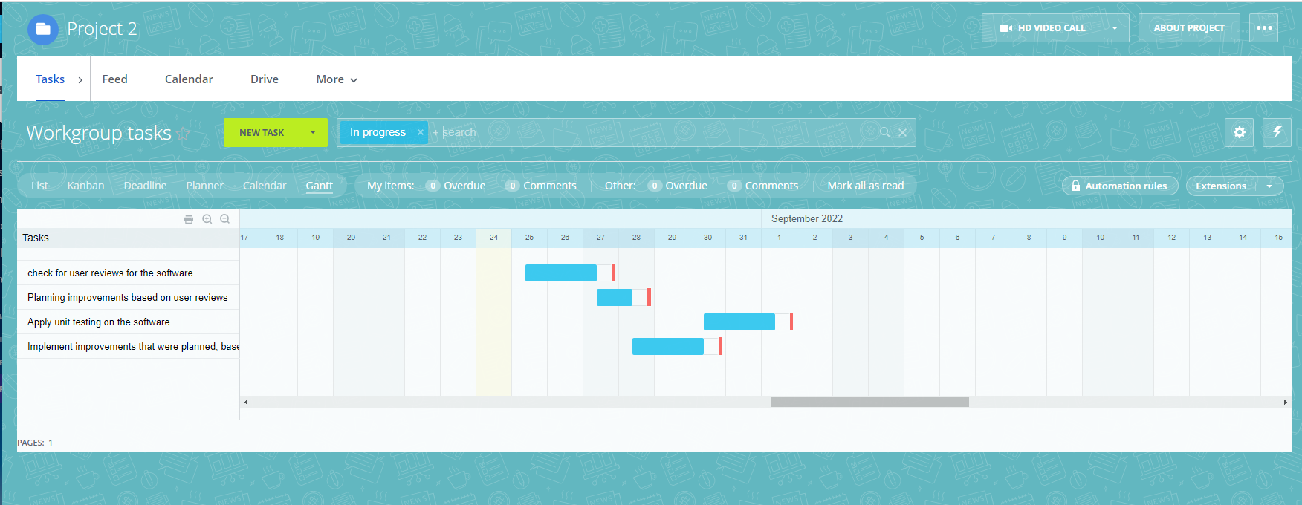

## ***Additional Reports***

### **Deadline:**

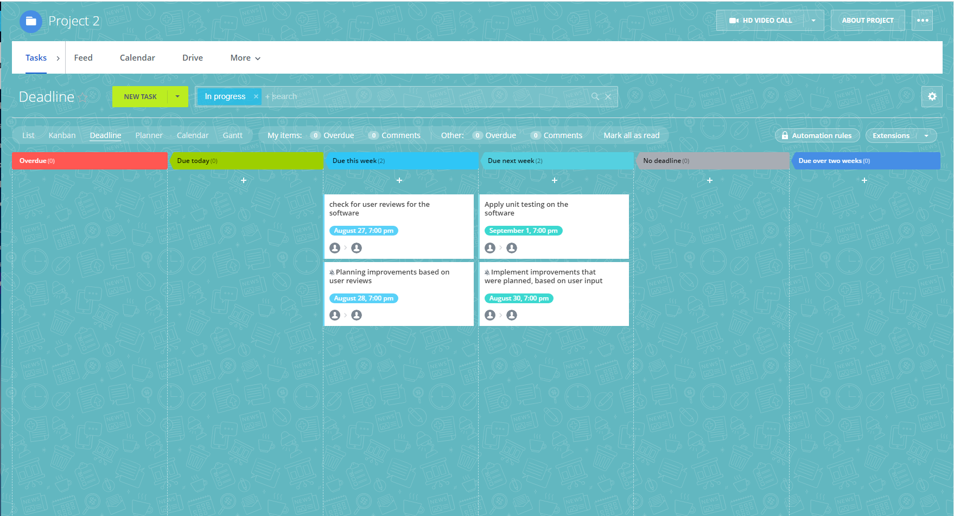

### **Planner:**

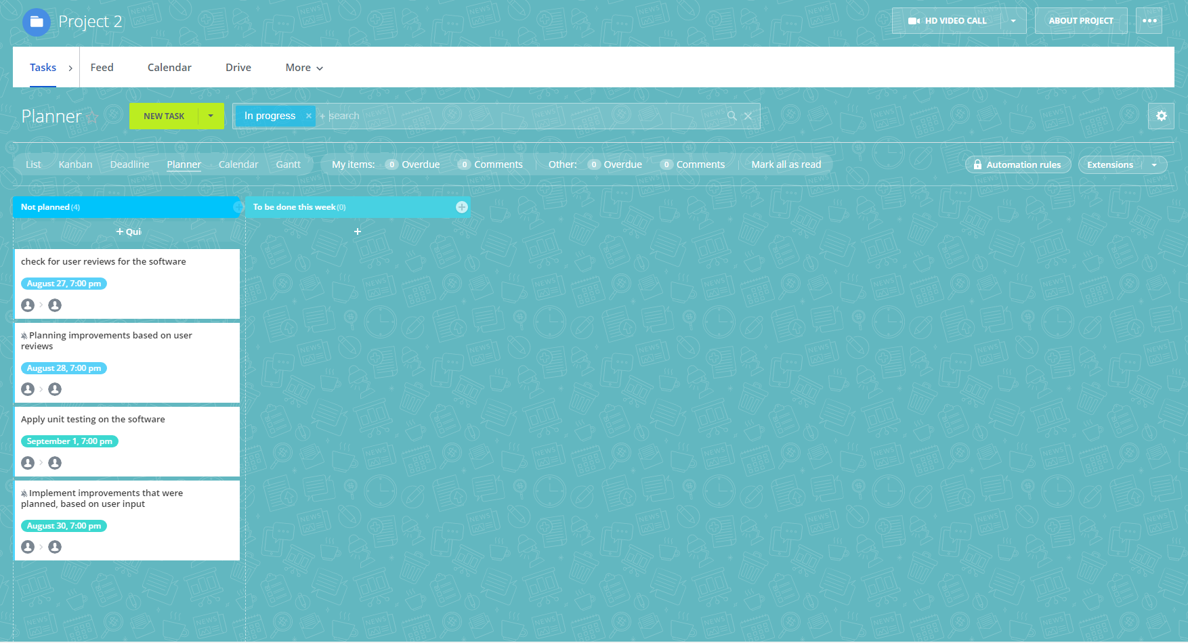

### **Calander:**

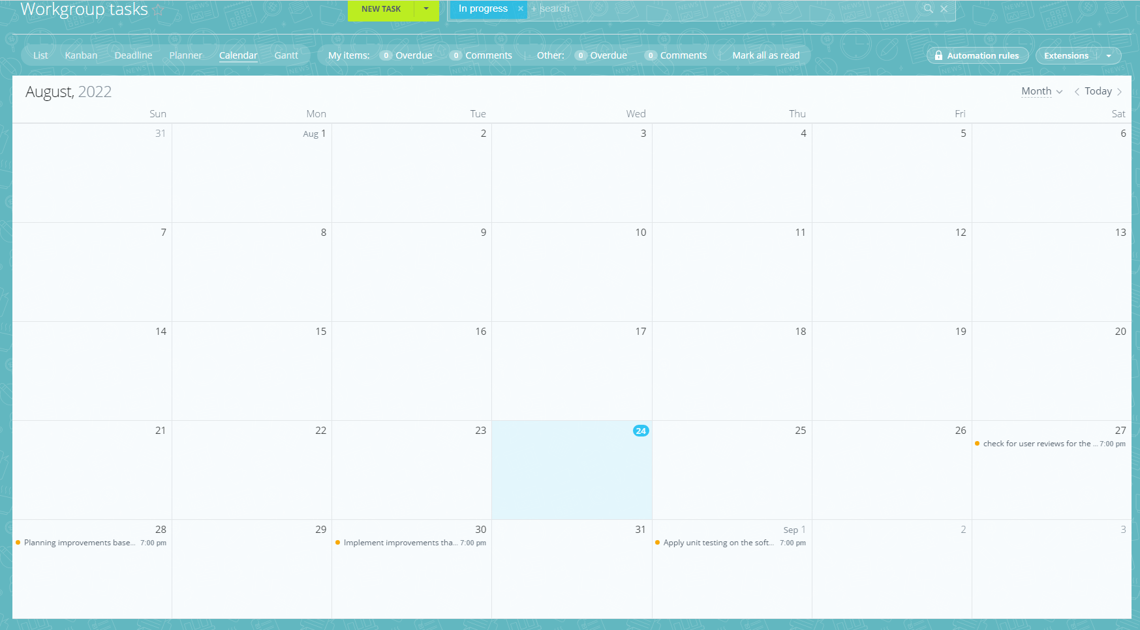

# **Scrum**

## **Calendar for Meetings**

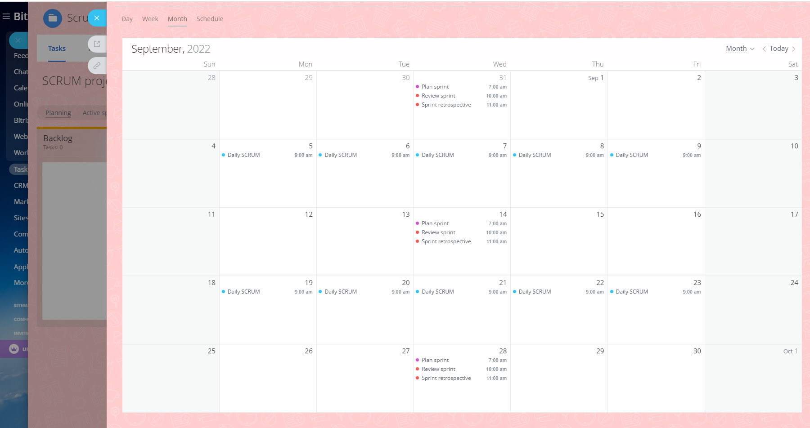

## **Planing Task**

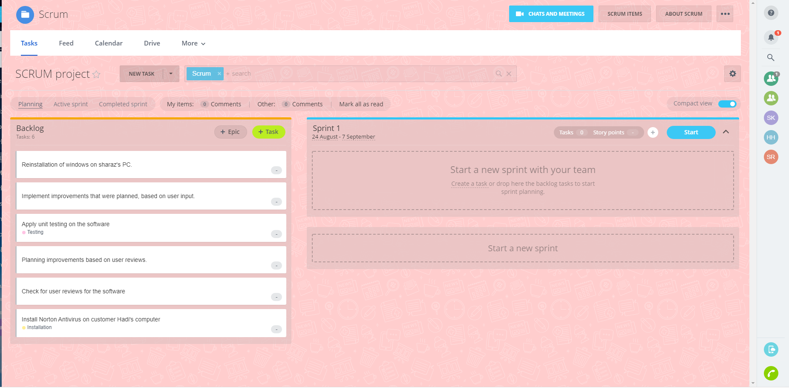

## **Make Sprint**

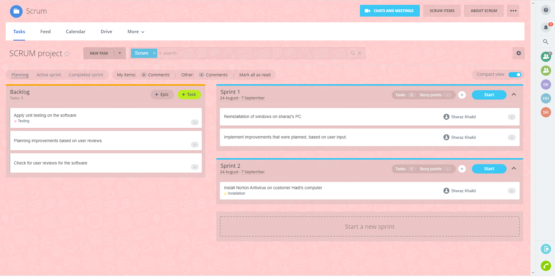

## **Start Sprint**

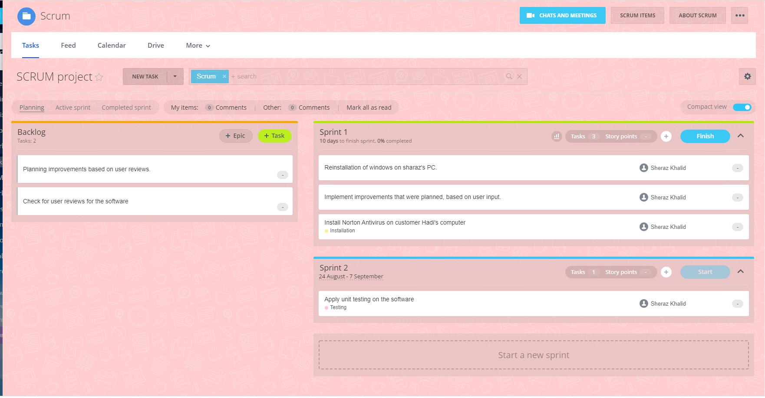

## **Active Sprint**

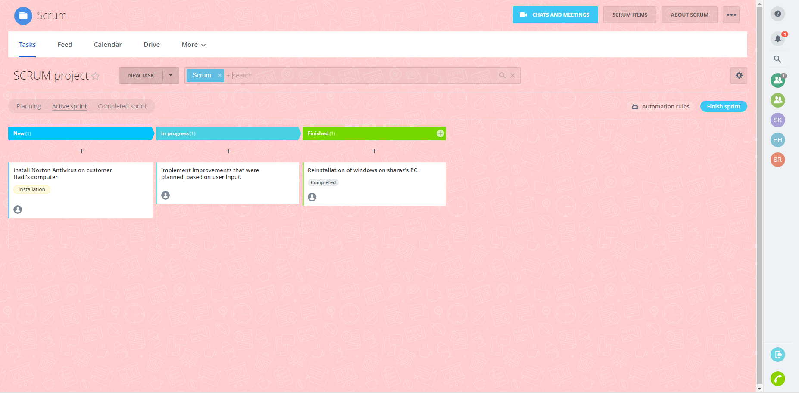

## **Completed Sprint**

